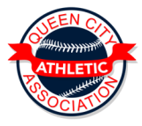

Queen City Baseball 2018
Pre-Season Tournament
April 27th, 28th, and 29th
A and AA Teams only…….3 game Guarantee
TBall $100.00 per Team
Machine Pitch $200.00 Team
9 Thru 14 $300.00 per Team
Deadline is April 15th

Age/Division _____________________________________
Team Name _____________________________________
Coach Name __________________PH #_______________
USSSA # ____________________ MUST HAVE USSSA #

Please Contact Phil Kelsay with any questions:
816-809-1604 or Littlekodiak33@gmail.com
Mail to: QCAA PO Box 142 Indep. Mo. 64051

